ANALISIS PERANCANGAN PERANGKAT LUNAK A
Tugas Perancangan Arsitektur dan Antar Muka Pengguna-Sistem Informasi
Finter.com



Dibuat oleh
Kelompok A02
5115100003 Dely Teja Mukti
5115100019 Farza Nurifan
5115100080 Yoga Samudra

Departemen teknik informatika
ftik – its
2017

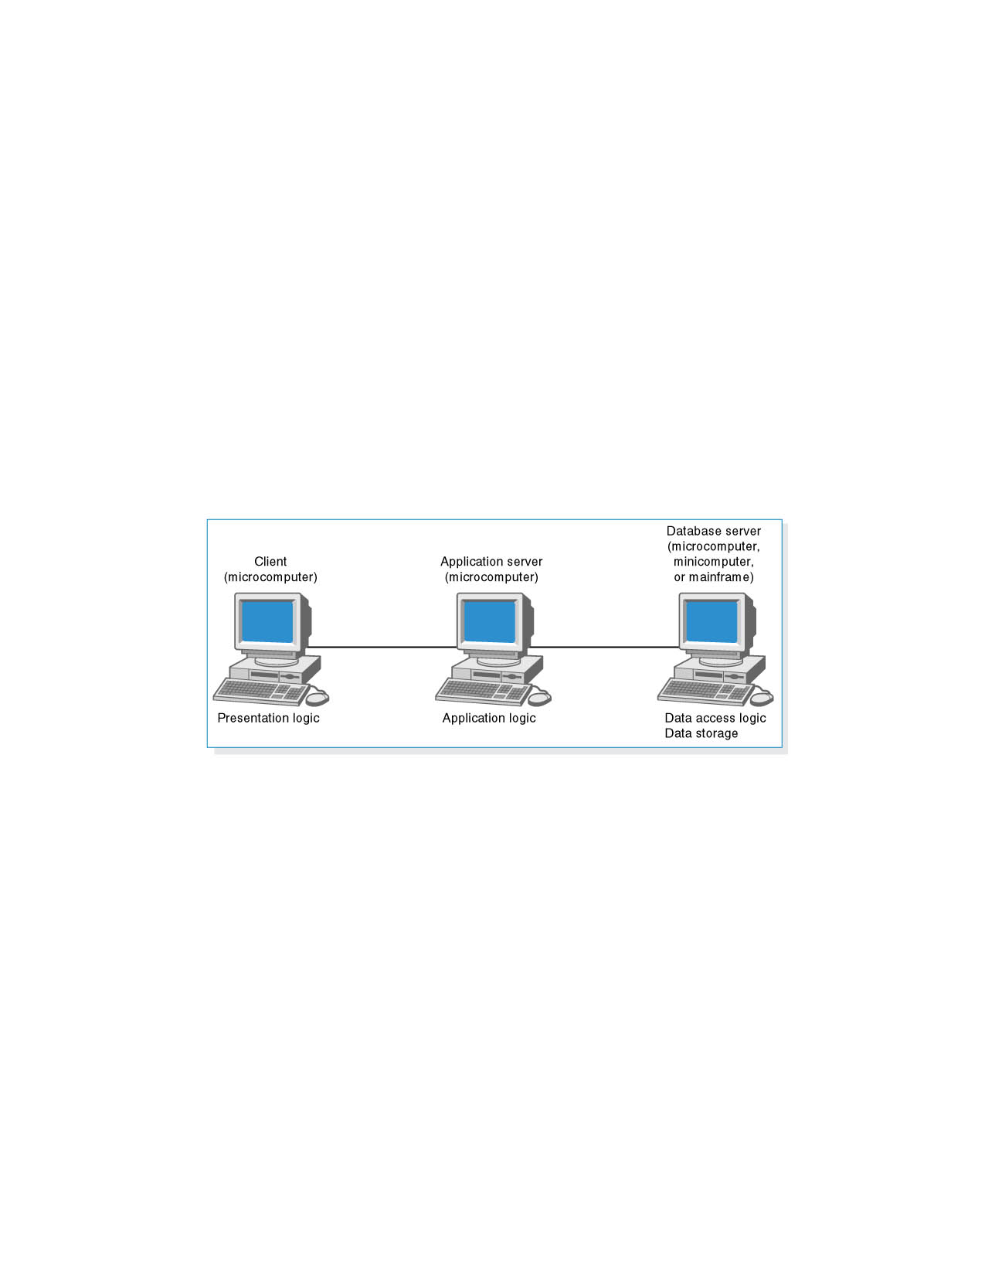
Dalam ​ ​Sistem ​ ​Informasi ​ ​kursus online finter.com ​ ​yang ​ ​akan ​ ​kami ​ ​buat, ​ ​kami ​ ​memilih
jenis ​ ​arsitektur ​ ​Three-tiered ​ ​Client ​ ​Server ​ ​Architecture.

- Presentation ​ ​logic ​ ​adalah ​ ​arsitektur disisi pengguna. ​ ​Pengguna ​ ​dapat ​ ​mengakses website ​ ​pada ​ ​komputer ​ ​maupun ​ ​mobile.
- ​Application ​ ​logic​ ​adalah ​ ​untuk ​ ​application ​ ​server. ​ ​Di ​ ​mana ​ ​pada ​ ​bagian ​ ​ini ​ ​menaruh
file-file ​ ​web, ​ ​untuk ​ ​mengelola ​ ​request ​ ​dari ​ ​client ​ ​dan ​ ​mengirimkan ​ ​message ​ ​berupa
file-file ​ ​html ​ ​ke ​ ​client.​
- ​Data ​ ​access logic, Data storage ​ ​untuk ​ ​database ​ ​server. ​ ​Digunakan ​ ​untuk ​ ​menyimpan ​ ​database ​ ​dan mengelola ​ ​database ​ ​yang ​ ​ada.

- Non-functional ​ ​requirements
Requirements | Client ​ ​Based | Application ​ ​Based | Database based
Operational
Requirements
System ​ ​Integration  Requirements | 
Portability
Requirements
Maintainability  Requirements |  | 
Technical
Environment
Requirements
Performance
Requirements
Speed ​ ​Requirements
Capacity
Requirements
Availability/Reliability
Requirements
Security ​ ​Requirements
Access ​ ​Control
Requirements
Encryption ​ ​and
Authentication
Requirements
Virus ​ ​Control
Cultural/Political
Requirements
Donation ​ ​Currency
Requirements

- Hardware ​ ​and ​ ​software ​ ​specification

 | Standard ​ ​Client | Standard ​ ​Web  Server | Standar  Database ​ ​Server
Operating  System | - Windows  - Linux  - Android | -Windows  - Linux | - Windows
Special  Software | - Chrome  - Safari  - Mozilla ​ ​Firefox | - Apache  - PHP  - Laravel  - Sublime | - MySql  - SqlYog
Hardware | - 2 ​GB ​ ​Memory  - Monitor  - Keyboard  - Mouse  - RAM ​ ​2​ ​GB  - Processor ​ ​intel  core ​ ​i3 | - 80​ ​GB ​ ​Disk  Drive  - Processor ​ ​intel  core ​ ​i5  - Monitor  - Keyboard  - Mouse  - RAM ​ ​4 ​ ​GB | - 500 ​ ​GB ​ ​Disk  Drive  - Processor ​ ​intel  core ​ ​i3  - Monitor  - Keyboard  - Mouse  - RAM ​ ​4​ ​GB
Network | - Kecepatan ​ ​500  Kbps | - Kecepatan ​ ​100  Mbps | - Kecepatan ​ ​100  Mbp

PERANCANGAN ​ ​ANTAR ​ ​MUKA ​ ​PENGGUNA
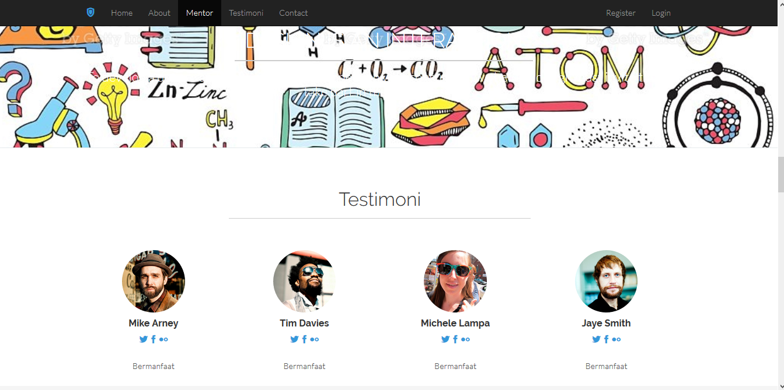
- Main Page Testimoni

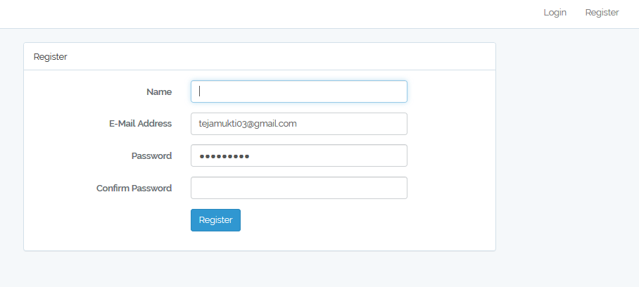
- register Page

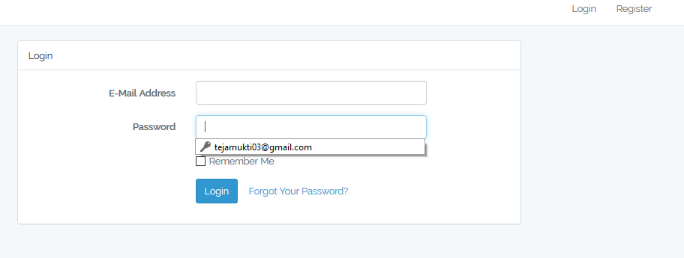
- login page

- Tes Online Page
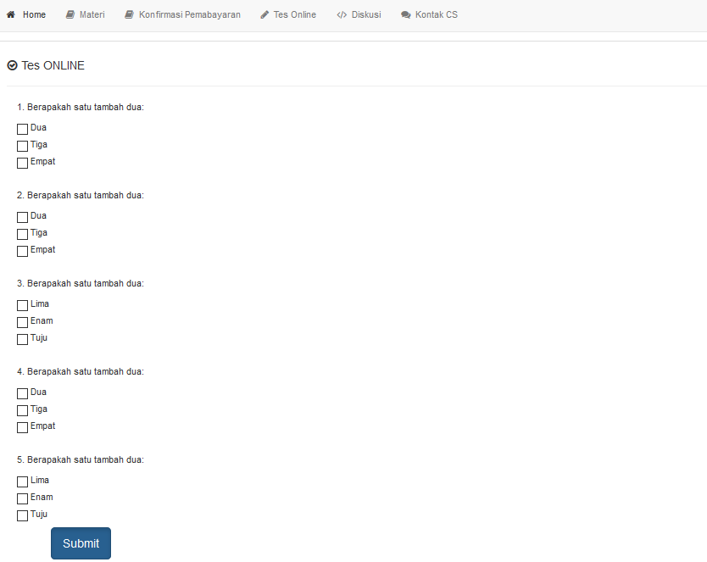
- Konfirmasi Pembayaran

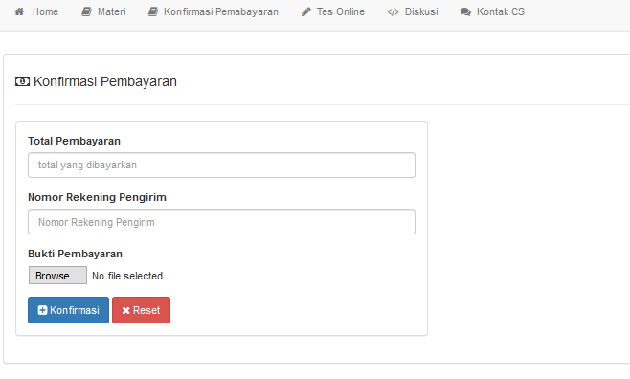
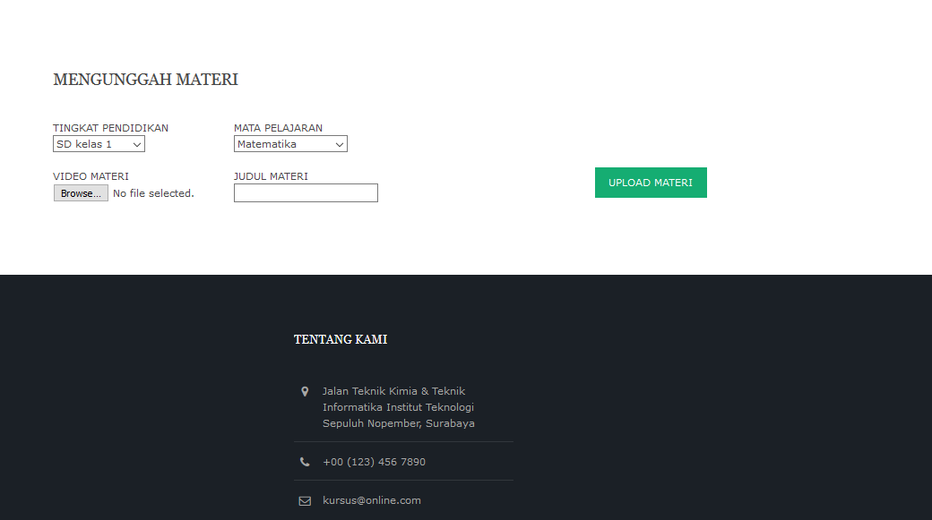
- Unggah Materi

- Materi User
